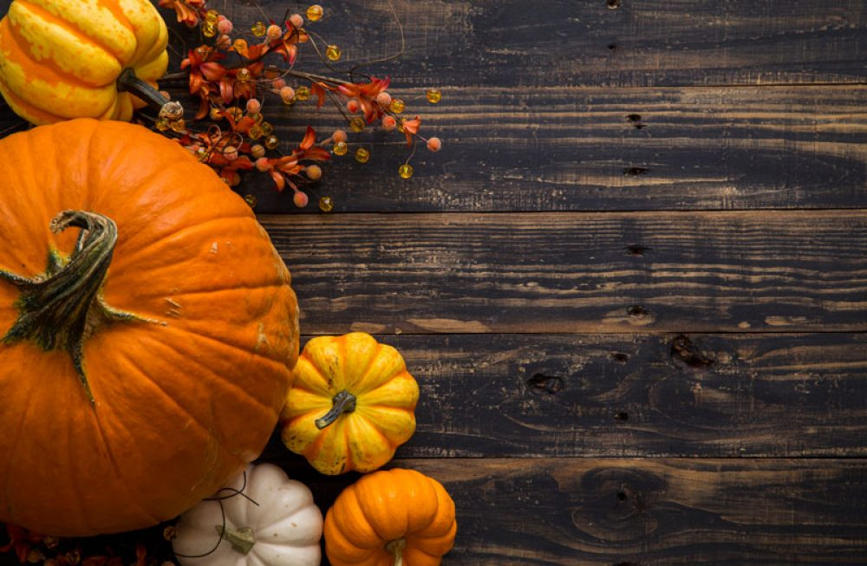
Individual Thanksgiving Day Meals Order Form
Name:
Phone #:
Email:
Package I: Herb Roasted Sliced Turkey, Traditional Gravy, Rustic Herb Stuffing, Mashed Potatoes, Thyme Shallot Butter Green Beans, Café Salad, Brioche Roll with side of Honey Butter, Cranberry Relish, and a slice of Pumpkin Pie - 25

Package II: Veggie Option, Stuffed Butternut Squash and Spinach Shells in a Parmesan Cream Sauce, Thyme Shallot Butter Green Beans, Café Salad, Brioche Roll with side of Honey Butter, and a slice of Pumpkin Pie – 25
(Quantity) Package I: (Quantity) Package II:
Payment Information
Credit Card Number: ___________________________________| Expiration: _____/______
Security Code: _____________ | Zip Code: ________________
Pickup on Wednesday November 24th BTW 11AM-7PM

